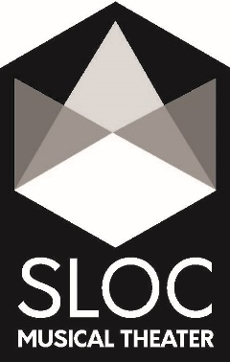
Schenectady Light Opera Company
Media Release Form

I, the undersigned, do hereby GRANT or DENY permission to SCHENECTADY LIGHT OPERA COMPANY to use the image and name of MYSELF or MY CHILD, ________________________________________, as marked by my selection below. Such use includes the display, distribution, publication, transmission, or otherwise use of photographs, images, and/or video taken of MYSELF or MY CHILD for use in materials that include, but may not be limited to, printed materials such as brochures and newsletters, videos, and digital images such as those on the Schenectady Light Opera Company website and social media pages (Facebook, Instagram, Twitter).
Deny permission to use my or my child’s image and name at all.

Grant permission to use my or my child’s image and name in the promotion of this
production.

__________________________________ ________________________________
Signature of Participant Date
(or guardian, if under 18)

__________________________________ ________________________________
Printed name of Participant Production Title
(or guardian, if under 18)

__________________________________ ________________________________
Phone Number E-mail Address

__________________________________ ________________________________
Street Address City/State/Zip Code

__________________________________ ________________________________
Signature of Producer Date

